The 2025 Provincial

Child and Youth Care Conference

gull lake centre, Alberta

October 3-5, 2025

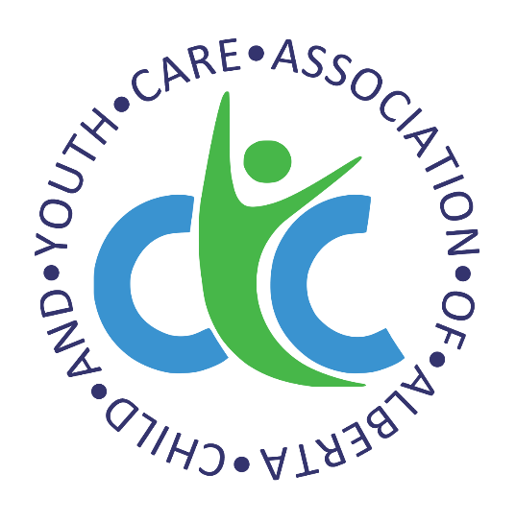

Engage and empower:

experiential and activity based

CyC practice

ENGAGE AND EMPOWER: EXPERIENTIAL AND ACTIVITY BASED CYC PRACTICE
Provincial Child and Youth Care Conference 2025

CALL FOR PAPERS

The Child and Youth Care Association of Alberta (CYCAA) is pleased to be hosting the Provincial Child and Youth Care Conference, October 3-5, 2025, at the Gull Lake Centre, located in the Village of Gull Lake, situated in the magnificent plains of Alberta just west of Lacombe. Gull Lake is in Treaty 6 territory, the traditional home, and meeting ground for many Indigenous peoples, including the Blackfoot, Cree, Dene, Stoney, and Métis.

We have chosen “Engage and empower: Experiential and activity based CYC practice” as our theme for the conference.

We invite Child and Youth Care professionals to submit proposals focused on advancing best practice and enhancing program delivery through innovative interventions and approaches. This conference will feature interactive workshops that explore how activity and creative interventions can be used when working with children, youth, and families. Presenters are encouraged to introduce new ideas, share emerging trends, and facilitate interactive activities and discussions. Through experiential learning, participants will gain practical knowledge and tools to strengthen their impact and effectiveness in the field.

We request that presenters consider the “experiential and activity based CYC practice” perspective to their presentation. Related topics may include evidence-based practice, innovative approaches to treatment, challenges to practice amid a pandemic, staff wellness, topics related to mental health and treatment of mental health issues, working with families, incorporation of traditional practices and ways of knowing, inclusion, and/or anti-oppressive practices.

To submit a presentation, please provide detailed information as outlined on the following page. Deadline for submissions is April 15, 2025.
Please be advised that the Conference Committee will select the successful presentations. The committee will review all potential presentations and will respond to all submissions with a decision.

Please forward your completed electronic submission with the subject line “2025 Conference Call for Papers” to admin@board-cycaa.com

ENGAGE AND EMPOWER: EXPERIENTIAL AND ACTIVITY BASED CYC PRACTICE
Provincial Child and Youth Care Conference 2025

CALL FOR PAPERS CHECKLIST

For all submissions, please provide the following:
- Presenter(s) biography (150 words maximum)
- Contact information (email, telephone/cell, mailing address)
- Agency/Organization/Affiliation for presenter(s)
- Session title and sub-title
- Content/Description of the presentation (250-400 words maximum)
- Preferred length of the presentation
☐ 1 hour - 60 minutes
☐ 2 hours – 120 minutes
- Seating design (i.e., theatre, semi-circle, tables, etc.)
- Minimum and maximum number of participants
- Audiovisual requirements NOTE: All presenters must provide their own laptop (no iPad, MacBooks etc.) and electronic or hard copy handouts
- Preferred date to present:
☐ October 3, 2025
☐ October 4, 2025
☐ October 5, 2025
Presenter Information:
- One presenter per workshop will be eligible for the reduced rate – details TBA.
- Seating design requests for delivery are subjected to availability at the venue.
- Presentations missing any of the above information will not be considered.

Please forward your completed electronic submission INCLUDING this checklist sheet with the subject line “2025 Conference Call for Presentations” to admin@board-cycaa.com

Deadline for presentation submissions is April 15, 2025

