The 2022 national Child and Youth Care Conference

Canmore, Alberta

October 5-7, 2022

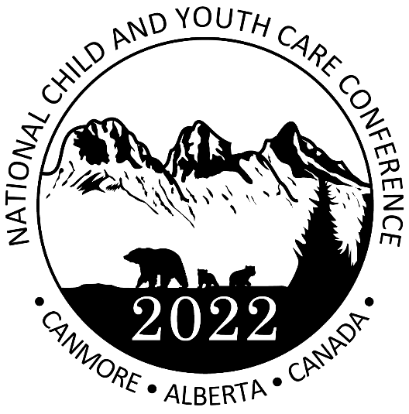 |  | 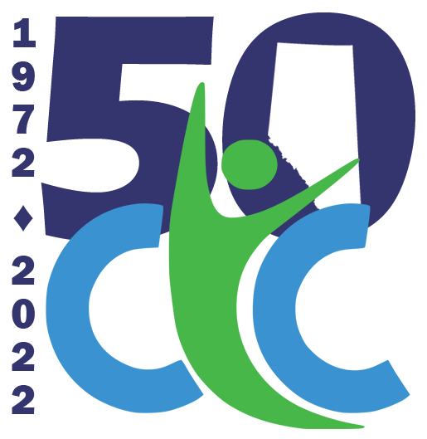

“Reaching for a Better Tomorrow”

“Reaching for a Better Tomorrow”
National Child and Youth Care Conference 2022

CALL FOR PRESENTATIONS

The Child and Youth Care Association of Alberta (CYCAA) is pleased to be hosting the National Child and Youth Care Conference, October 5-7, 2022, in Canmore, Alberta, Canada, situated in the magnificent Rocky Mountains west of Calgary, on the ancestral lands of the Blackfoot Confederation The conference signifies our hope to come together once again as a collective for connection, inspiration and learning. It will also be the 50th Anniversary celebration for CYCAA!

We have chosen “Reaching for a Better Tomorrow” as our theme for the conference. It is the original tagline from 1972 for the then newly created Child and Youth Care Association of Alberta. How fitting it is to bring this back at a time when our sector has experienced so many challenges, especially during almost two years in a global pandemic. Our goal to help children, youth and families aspire to a brighter future, a better tomorrow, remains as important today as it was 50 years ago. Our profession has made great strides over the decades and yet there is still much to learn. We invite you to continue this journey with us.

Wouldn’t it be wonderful to boldly plan for a traditional conference? We desire to create an even better experience for delegates than our 2012 National Conference held in the same venue. We hold on to the hope that most of us will be able to be physically together, safely, in October. However, we must also acknowledge the ever-changing situation regarding travel and gathering advisories, as well as the additional financial strains there have been for many. Therefore, both in-person and virtual delivery streams will be available for the conference, and this call for presentations will require you to identify the option that best suits your preference for delivery.

We request that presenters consider the “Reaching for a Better Tomorrow” perspective to their presentation. Related topics may include evidence-based practice, innovative approaches to treatment, challenges to practice amid a pandemic, staff wellness, topics related to mental health and treatment of mental health issues, working with families, incorporation of traditional practices and ways of knowing, inclusion, and/or anti-oppressive practices.

To submit a presentation, please provide detailed information as outlined on the following page. Deadline for submissions is FEBRUARY 15, 2022.
Please be advised that the Conference Committee will select the successful presentations. The committee will review all potential presentations and will respond to all submissions with a decision.

Please forward your completed electronic submission with the subject line “2022 Conference Call for Presentations” to call-for-papers-2022@board-cycaa.com

Deadline for presentation submissions is FEBRUARY 15, 2022

“Reaching for a Better Tomorrow”
National Child and Youth Care Conference 2022

CALL FOR PRESENTATIONS CHECKLIST

The October 5-7, 2022, National Child and Youth Care Conference will have two unique streams of delivery – face-to-face (F2F) in Canmore, AB, and virtually, to accommodate attendees who may wish to remain in their home community while participating in conference sessions. In the case of restrictions on large gatherings being imposed, we request all face-to-face presenters be prepared and make prior arrangements to allow a switch to a virtual presentation.
For all submissions, please provide the following:
- Presenter(s) biography (150 words maximum)
- Contact information (email, telephone/cell, mailing address)
- Agency/Organization/Affiliation for presenter(s)
- Clearly identify your delivery preference:
☐ Face to face in Canmore; AB and I am willing to present virtually if restrictions require.
☐ Face to face in Canmore, AB but decline virtual delivery if I am unable to deliver F2F.
☐ Virtual delivery regardless of any potential restrictions.
- Session title and sub-title
- Content/Description of the presentation (250-400 words maximum)
- Preferred length of the presentation
☐ 1.5 hours - 90 minutes
☐ 3 hours – 180 minutes
- If F2F delivery, seating design (i.e., theatre, semi-circle, tables, etc.)
- Minimum and maximum number of participants
- Audiovisual requirements NOTE: All presenters must provide their own laptop (no iPad, MacBooks etc.) and electronic or hard copy handouts.
- Preferred date to present:
☐ October 5, 2022
☐ October 6, 2022
☐ October 7, 2022
Presenter Information:
- One presenter per workshop will be eligible for the reduced rate – details TBA.
- Seating design requests for F2F delivery are subjected to availability at the venue.
- Presentations missing any of the above information will not be considered.

Please forward your completed electronic submission INCLUDES this checklist sheet with the subject line “2022 Conference Call for Presentations” to call-for-papers-2022@board-cycaa.com

Deadline for presentation submissions is FEBRUARY 15, 2022

